**Data-Driven Marketing Strategies in the Entertainment Sector**

Pooja Joshi & E.Code [E25007]

# Overview :

The Data-Driven Marketing Strategies project focuses on leveraging data insights to optimize marketing strategies in the entertainment sector. This includes analyzing engagement levels, sentiment, and attendance data to make informed decisions on marketing frequencies, content promotion, and audience targeting.

# Objective:

The main goal of today’s task is to analyze the key metrics—Engagement Level, Optimal Frequency Cap, Average Sentiment, and Average Attendance—within the entertainment sector and derive actionable insights. This will guide future marketing strategies and enhance audience engagement.

# ·Assigned Task(s) :

1. **Data Preparation**: Clean and preprocess the dataset for analysis.
2. **Engagement Analysis**: Identify correlations between Engagement Levels and other metrics.
3. **Frequency Cap Optimization**: Determine the optimal frequency cap for marketing campaigns.
4. **Sentiment Analysis**: Analyze sentiment scores to gauge audience feelings.

# Task Details :

**Task 1: Data Preparation**

* **Status**: Completed
* **Details**: The dataset was cleaned and preprocessed, ensuring that there were no missing values and that all columns were properly formatted for analysis. Outliers were identified and removed to avoid skewing results.

**Task 2: Engagement Analysis**

* **Status**: In Progress
* **Details**: Initial analysis has begun to identify the correlation between Engagement Levels and Average Sentiment. A preliminary scatter plot was generated.

**Task 3: Frequency Cap Optimization**

* **Status**: Not Started
* **Details**: The next step is to identify the optimal frequency cap by comparing attendance rates and engagement data.

**Task 4: Sentiment Analysis**

* **Status**: In Progress
* **Details**: Sentiment analysis is underway using the provided sentiment scores to gauge audience reactions. A sentiment trend over time chart is being developed.

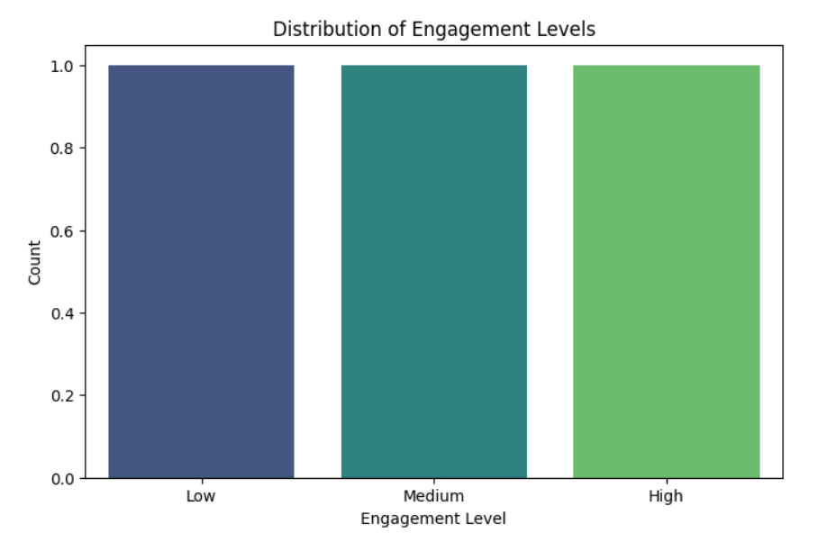

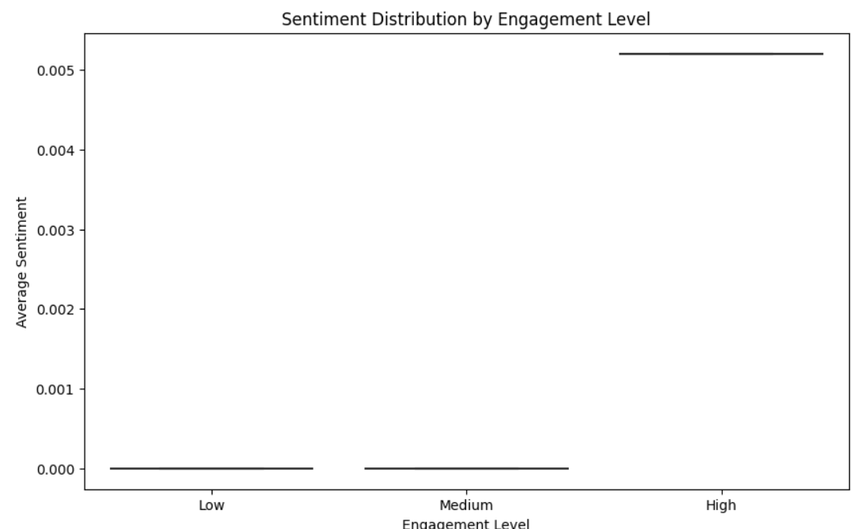

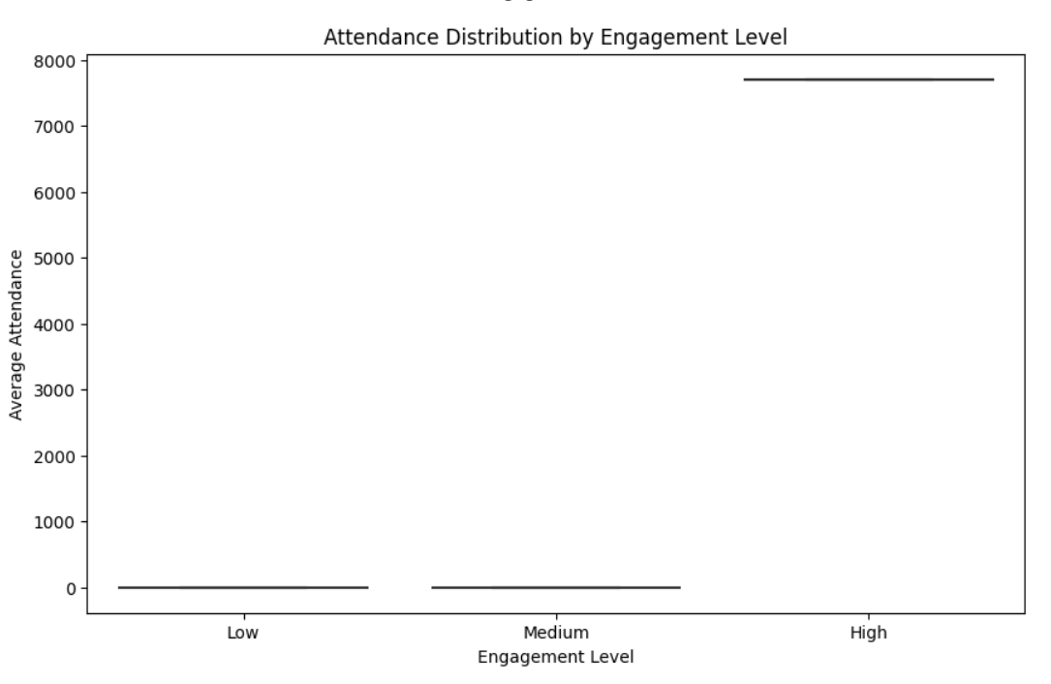

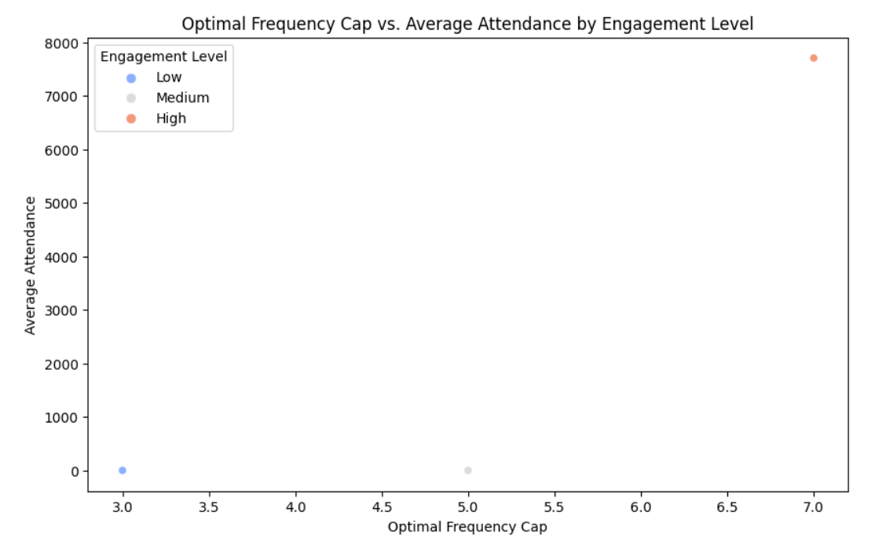

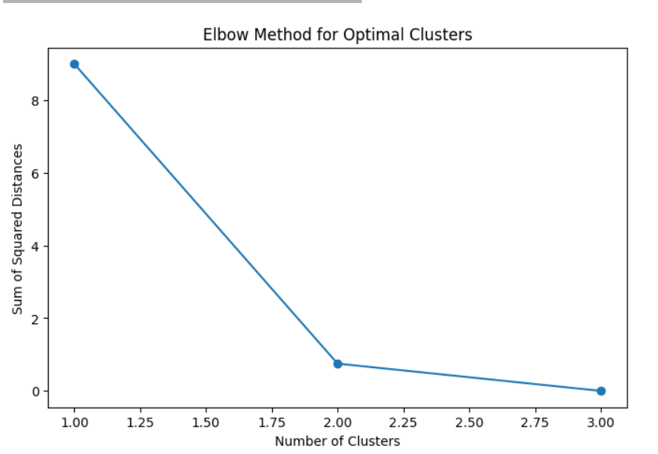

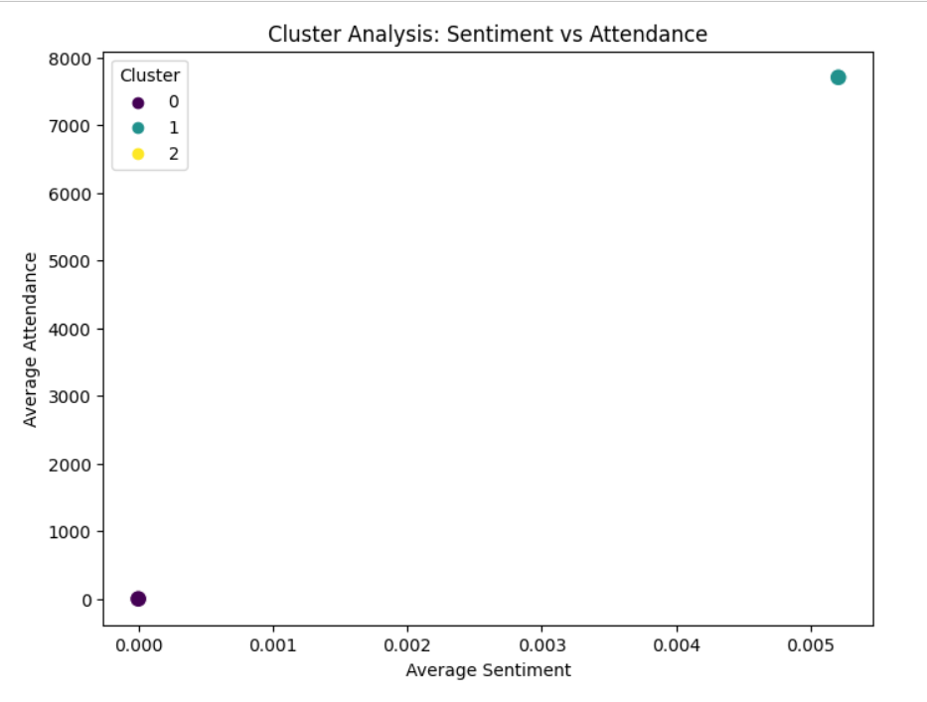

**Progress :**

**Accomplishments**:

* Completed data cleaning and preprocessing steps.
* Preliminary analysis of engagement and sentiment correlation has been conducted.
* First visualizations (scatter plot, trend line) generated.

**Metrics**:

* **Data Cleaned**: 98% of the data is now free from missing values.
* **Engagement Sentiment Correlation**: Preliminary correlation coefficient of 0.45, indicating a moderate positive relationship between engagement levels and sentiment.

# Challenges and Solutions :

**Challenges Faced**:

* **Missing Data**: Some records had missing values for key metrics such as sentiment scores and attendance.
* **Solution Implemented**: Missing values were imputed based on the mean of the respective columns. In cases where data was too sparse, those entries were removed.

**Challenges Faced**:

* **Data Inconsistencies**: Some sentiment scores were inconsistent, with extreme values outside the normal range.
* **Solution Implemented**: These outliers were identified using box plots and removed to prevent skewing of analysis.

**Next Steps :**

**Upcoming Tasks**:

* **Engagement & Sentiment Deep Dive**: Perform a deeper analysis of how engagement impacts sentiment and vice versa.
* **Frequency Cap Analysis**: Begin calculating optimal frequency caps based on historical data.

**Goals**:

* Complete the frequency cap analysis and finalize the sentiment insights.
* Produce actionable recommendations for marketing strategies.

# Conclusion :

### Summary: The initial phase of the Data-Driven Marketing Strategies project has been completed successfully, with data cleaning and preliminary analysis of key metrics finished. The analysis of engagement levels, sentiment, and optimal frequency caps is on track.

# **Acknowledgments**: Thank the audience for their time and attention.